**MONGODB**

**Name: DARA VAMSI Date: 12-06-2025**

**Reg No: 22BCB7293**

**Gmail: vamsi.22bcb7293@vitapstudent.ac.in**

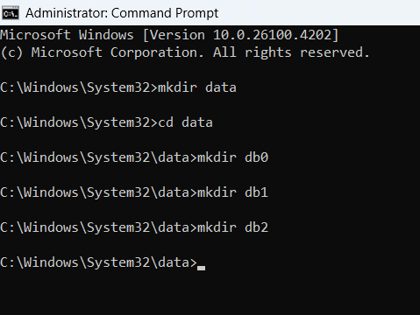

Microsoft Windows [Version 10.0.26100.4202]

(c) Microsoft Corporation. All rights reserved.

C:\Windows\System32>mkdir data

C:\Windows\System32>cd data

C:\Windows\System32\data>mkdir db0

C:\Windows\System32\data>mkdir db1

C:\Windows\System32\data>mkdir db2

C:\Windows\System32\data>

Terminal 1:

mongod.exe --replSet myReplSet --dbpath D:\Temp\data\db0 --port 27017 --bind_ip localhost

Terminal 2:

mongod.exe --replSet myReplSet --dbpath D:\Temp\data\db1 --port 27018 --bind_ip localhost

Terminal 3:

mongod.exe --replSet myReplSet --dbpath D:\Temp\data\db2 --port 27019 --bind_ip localhost

Run in new Terminal:

mongosh --port 27017

**Replica code:**

rs.initiate({

_id: "myReplSet",

members: [

{ _id: 0, host: "localhost:27017" },

{ _id: 1, host: "localhost:27018" },

{ _id: 2, host: "localhost:27019" }

]

})

